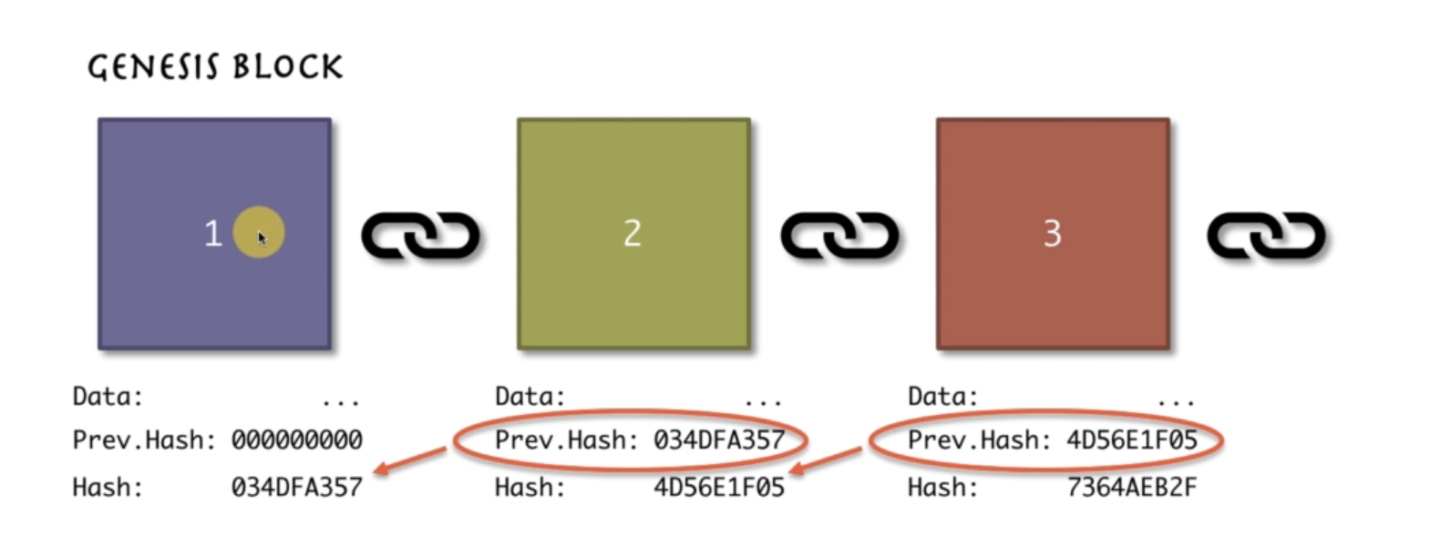

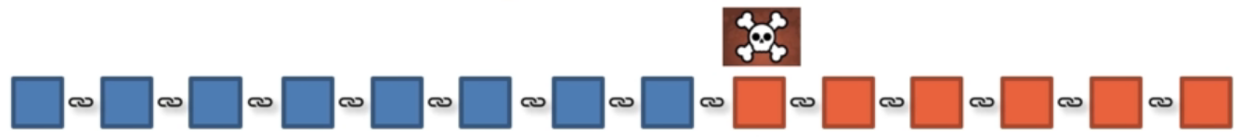  
Immutable ledger: You have to change every block after the block that you want to change. Hence, this is almost not possible.

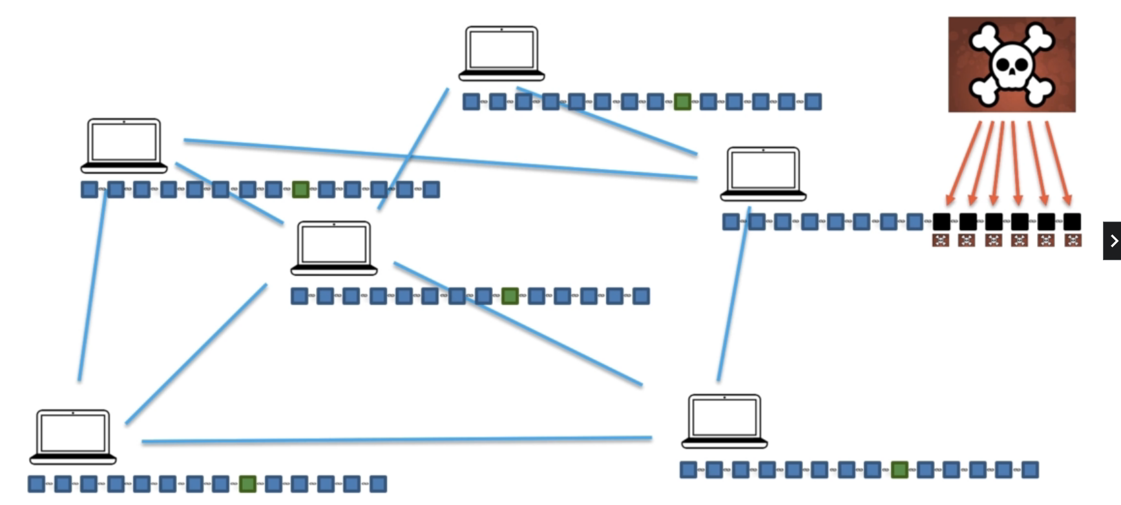

Distributed P2P Network: All the blockchain is copied over every devices. Even if a chain is successfully changed, it won’t work because all the other chains aren’t changed. Therefore, you have to change more than a half of all the blockchains to really change the blockchain.

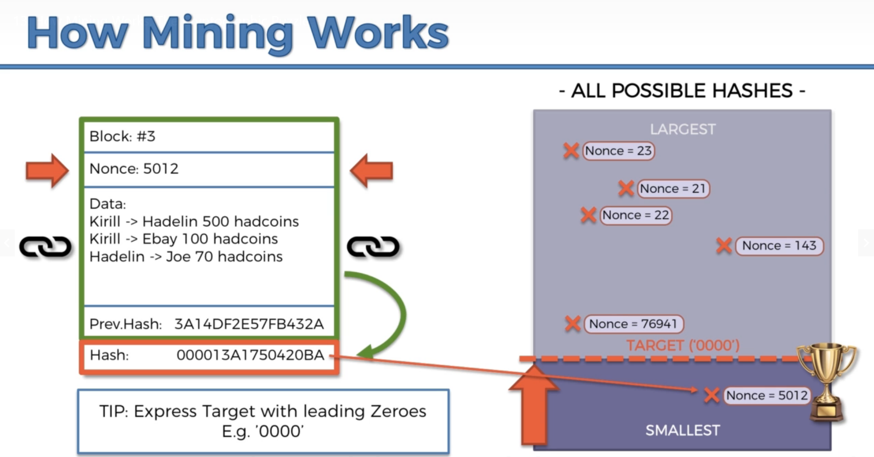

Nonce: Number used only once. Block number, nonce, data, prev. hash are put together to generate a hash number. But only nonce can be chosen. The others cannot be changed.

What’s mining: A blockchain will randomly choose a target. Then the hash should be smaller than the target to be valid. Hence, computers should keep randomly choosing nonce to make the hash smaller than the target.

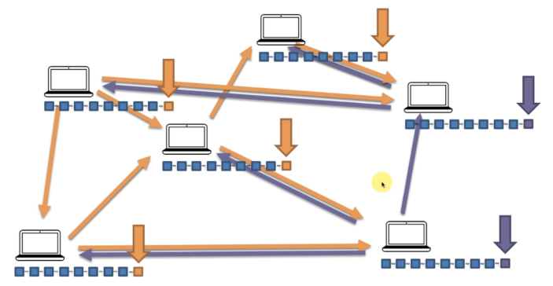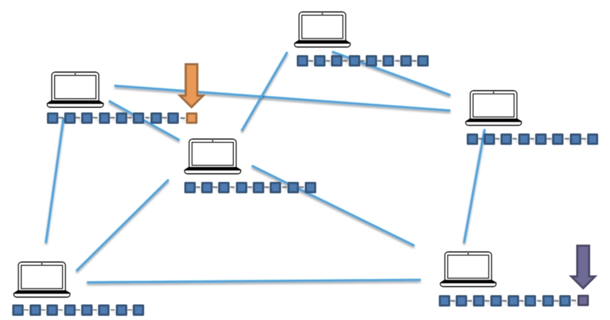

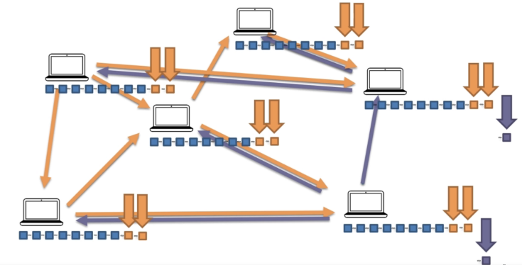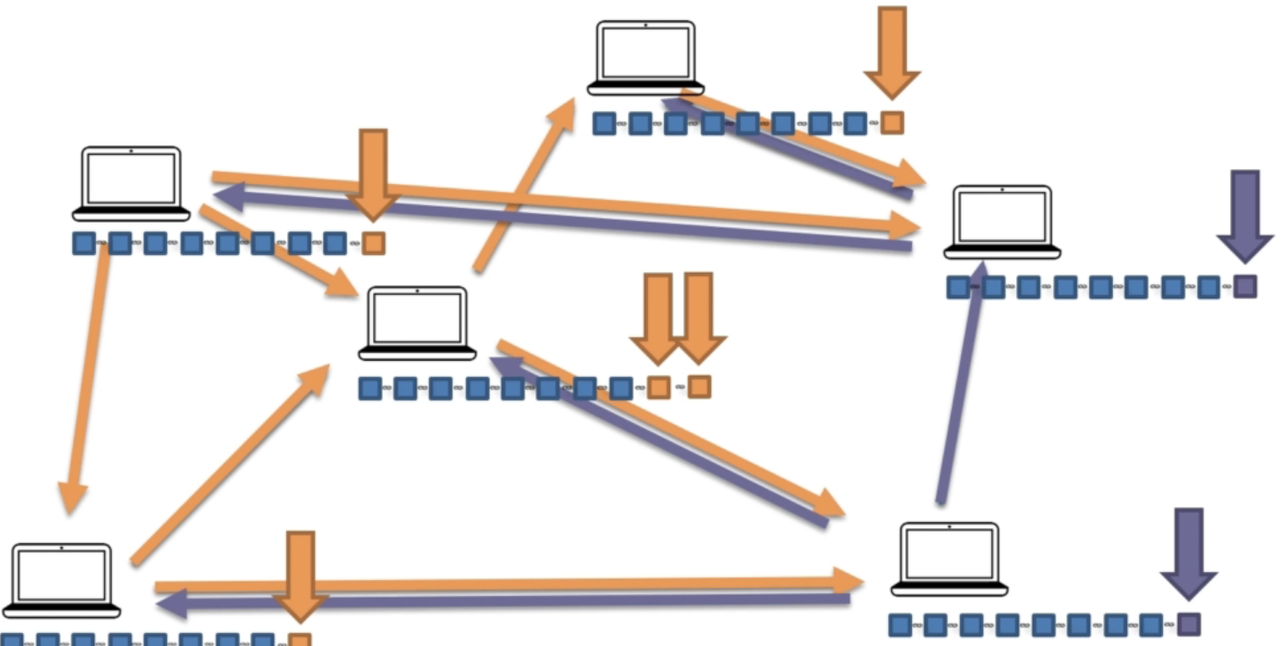

Consensus protocol: When two blocks are added at the same time, it will wait until another block is added. Then the longer chain wins. This means the party with more than fifty percent among all the devices will win.

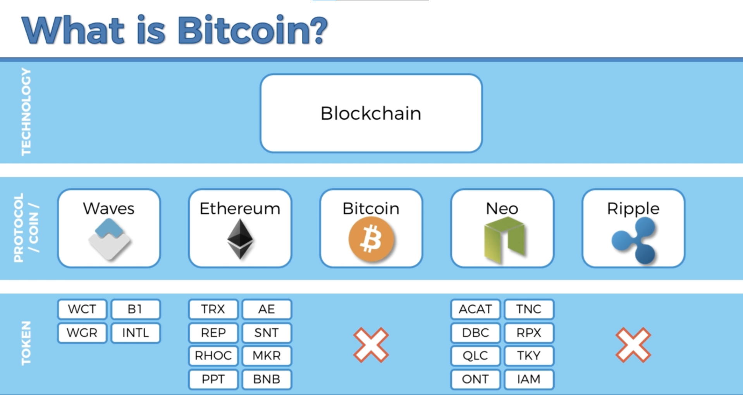

Mining difficulty:

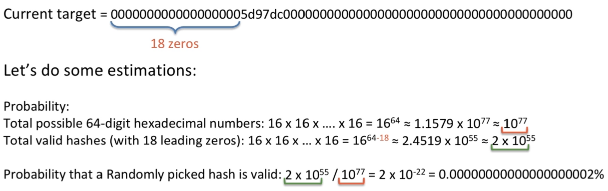

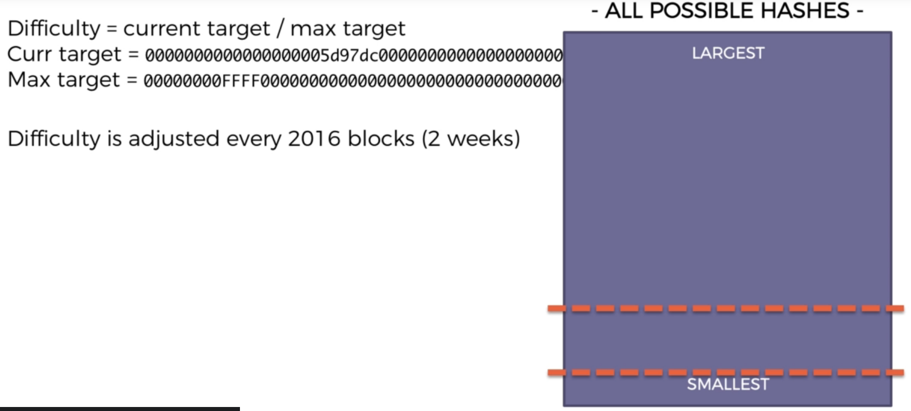

Every 10 minutes generates one block. 2016\*10 = 60\*24\*14

Mining pool: Many devices add up to a mining pool. If one of the mining pool finds the golden nonce, the reward is split proportionally by the computing power of devices.

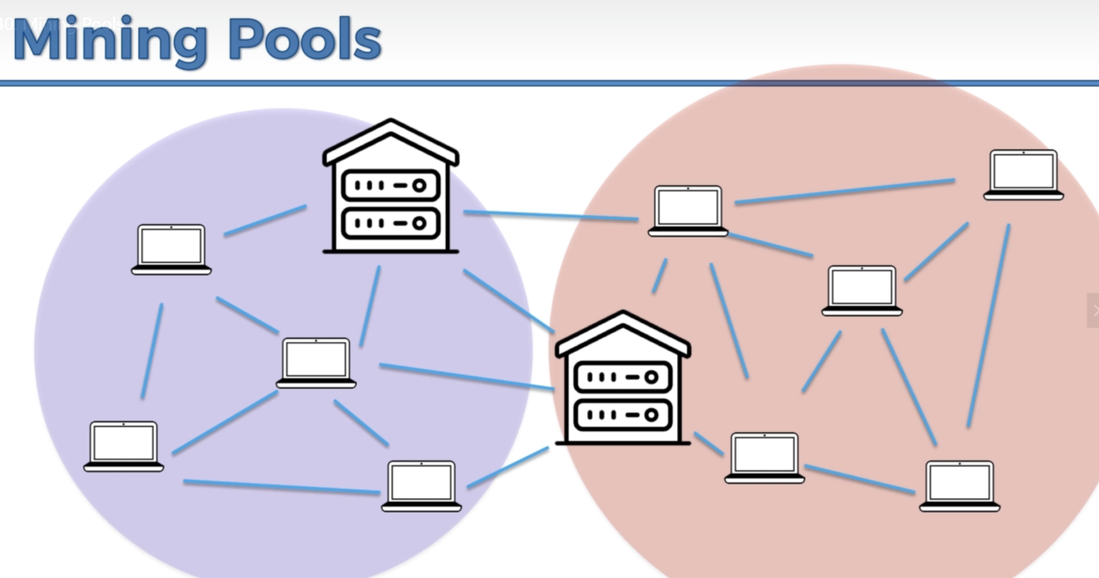

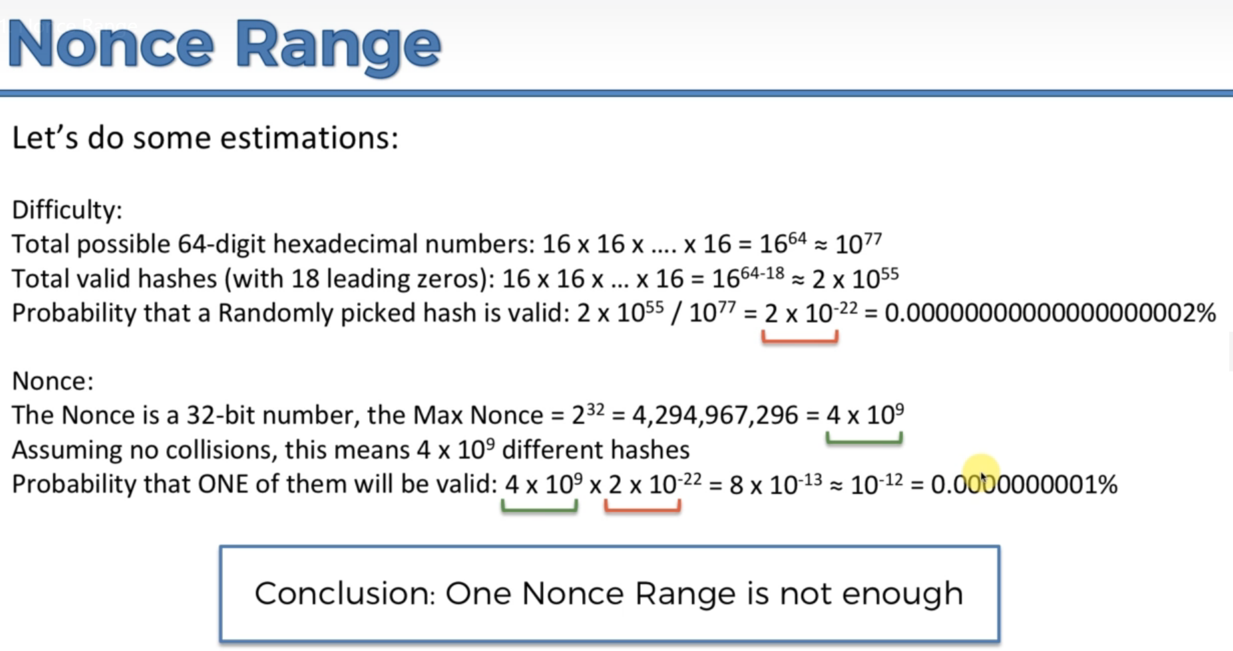

Nonce isn’t enough. Solution: Add timestamp field, the timestamp is in unix time. It will increment every one second.

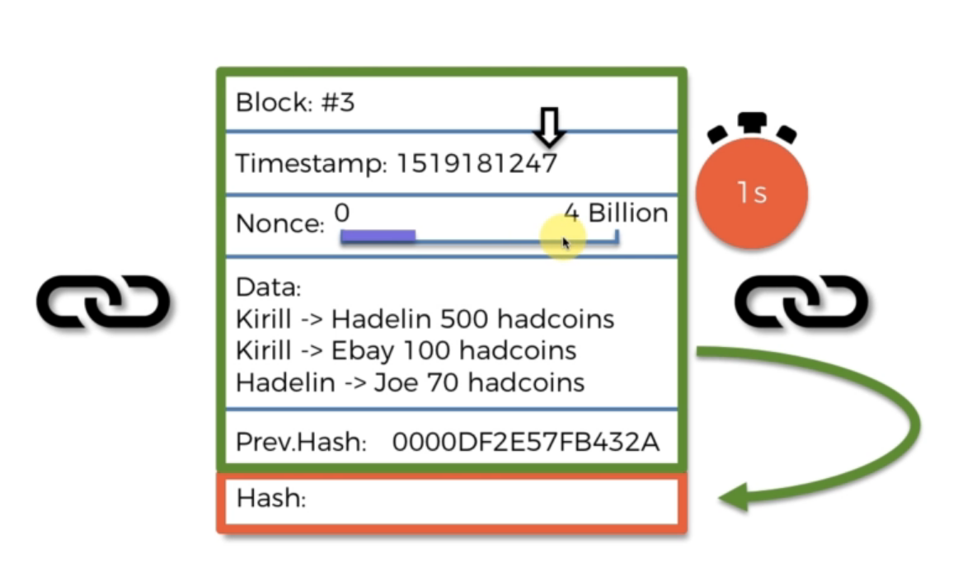

But that’s still not enough. Solution: Change data configuration. When a second hasn’t gone through but 4billion kinds of nonce are finished trying, then change the lowest fees transaction in the data to the one that is just lower than it. When finally reached one second, it’ll start all over.

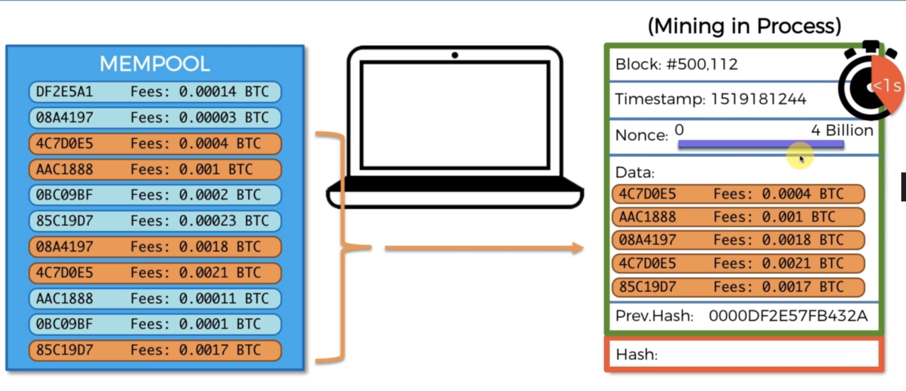

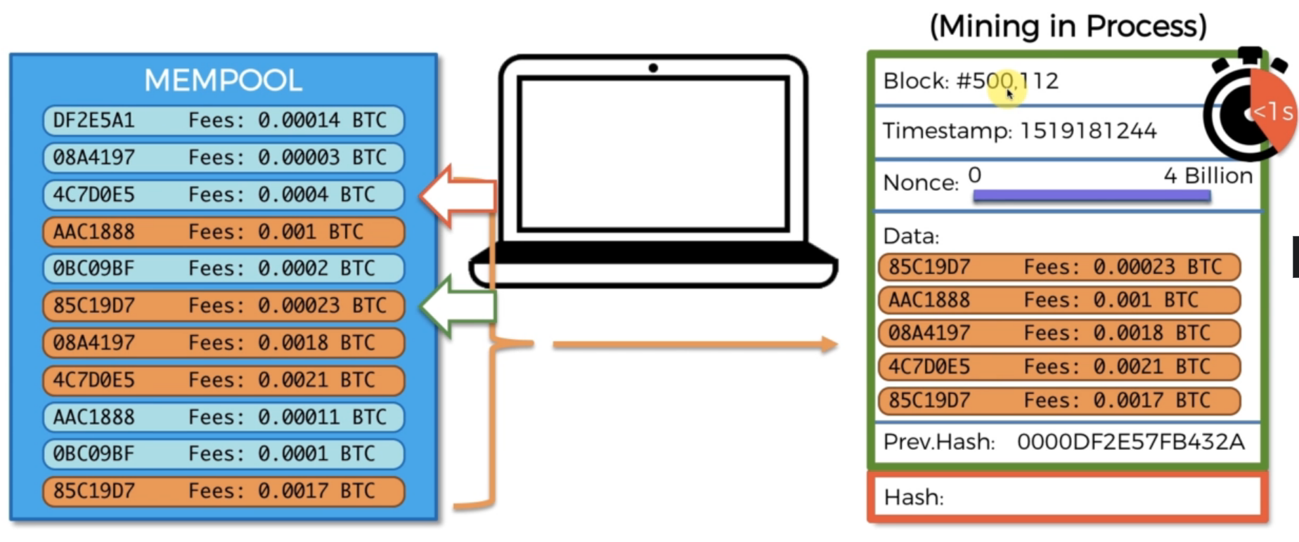

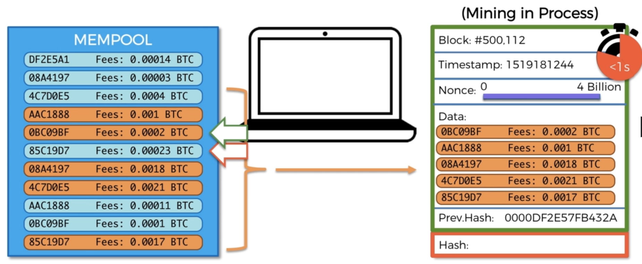

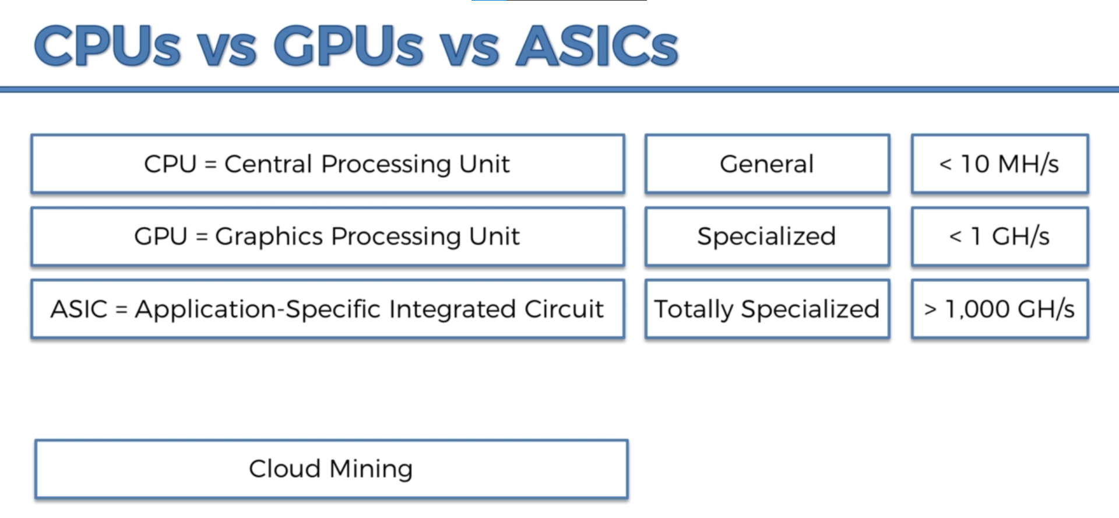

The 51% Attack: <https://www.udemy.com/course/build-your-blockchain-az/learn/lecture/9657462#questions/13439472>

UTXO: Unspent transaction output

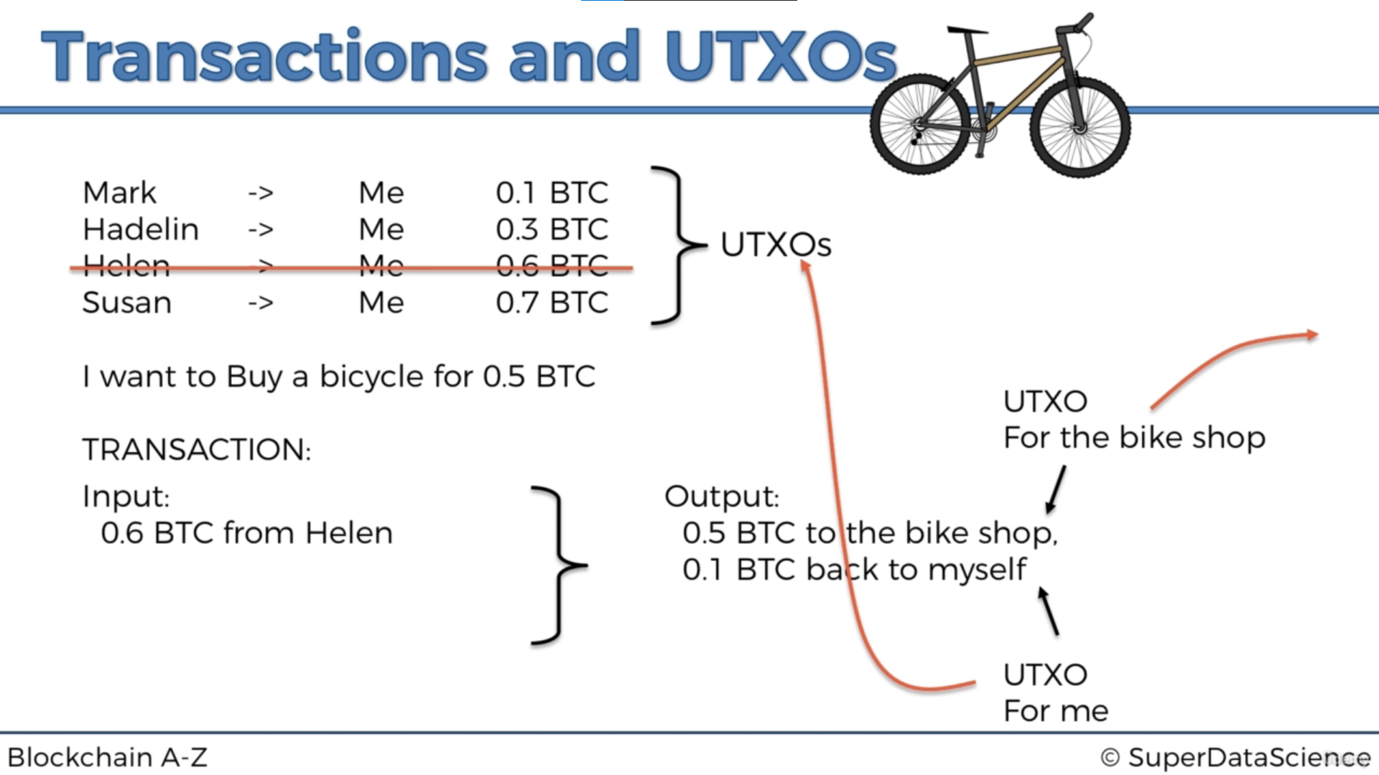

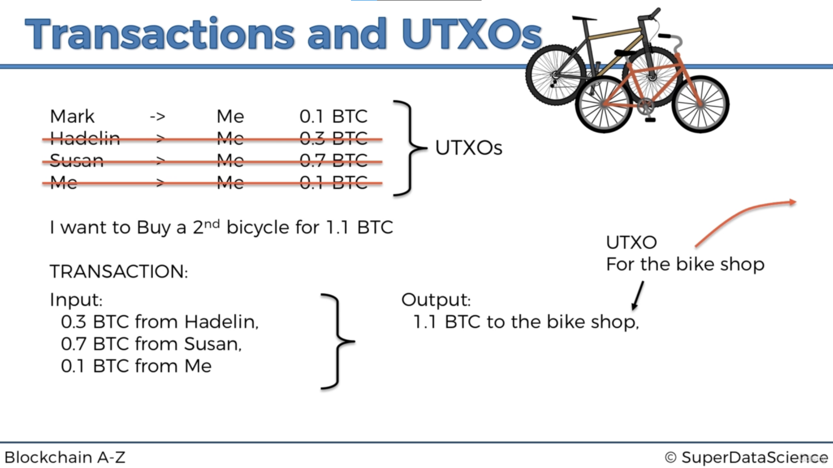

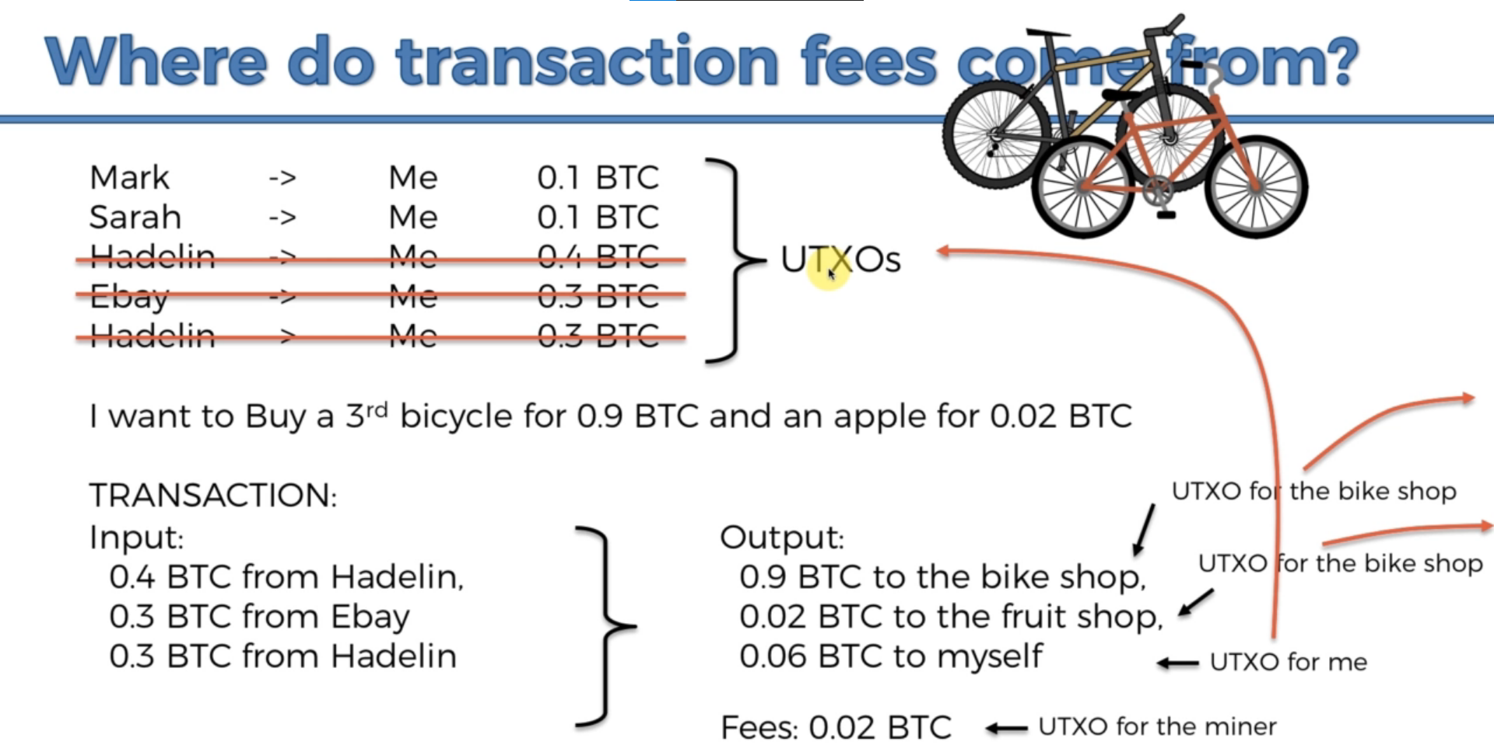

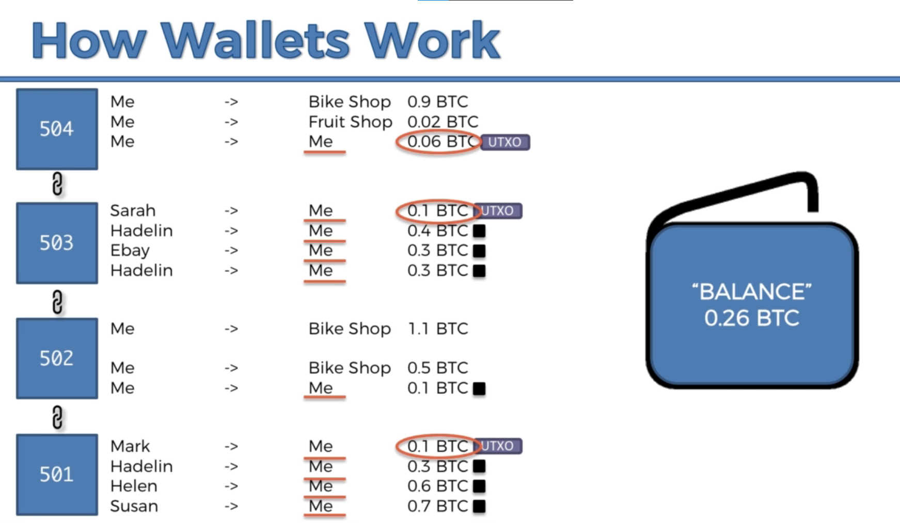

Because signature and public key are too big comparing to the transaction itself, they are segregated and transport by bitcoin network.

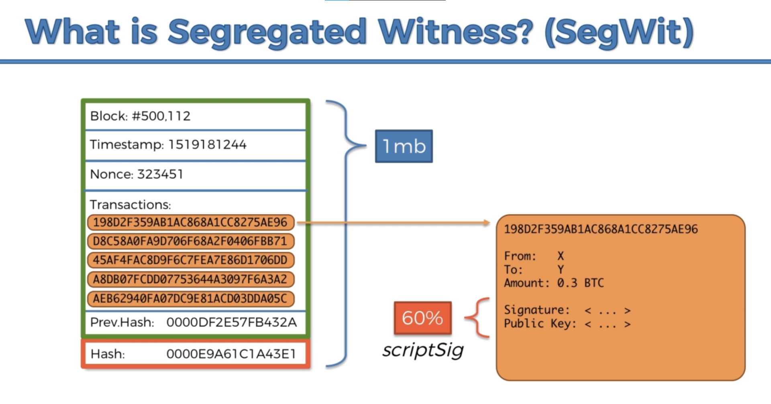

Private key to public key: elliptic curve cryptography; public key to address: SHA256

Bitcoin transact with others using address, not public address because elliptic function may be vulnerable. If everyone has your public key, someone may uses public key and reverse into private key. So using address is safer.

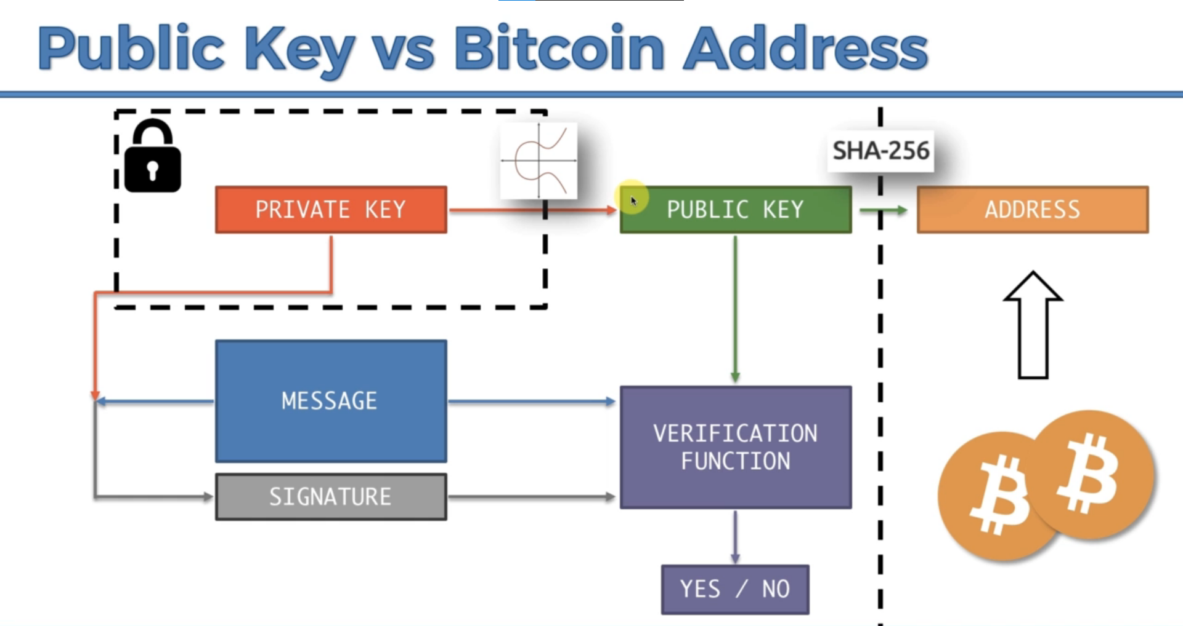

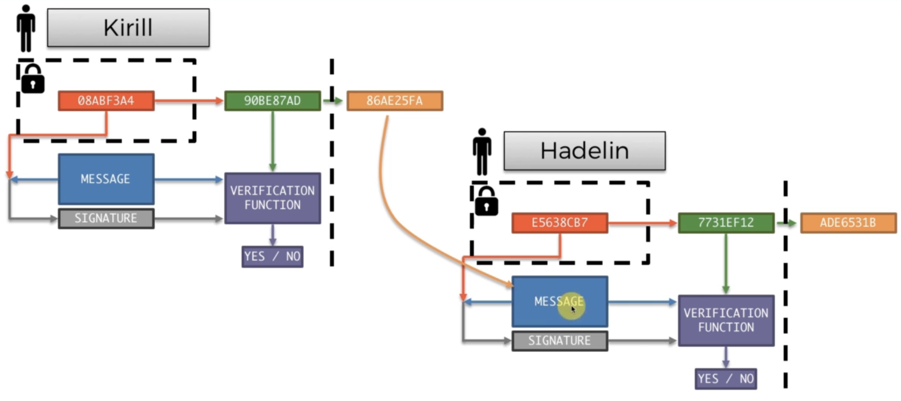

When you keep transact with the same object or in the same area, some people may derive from the information and endanger your anonymity. Therefore, they use HD wallets, which has multiple private keys to prevent this problem.

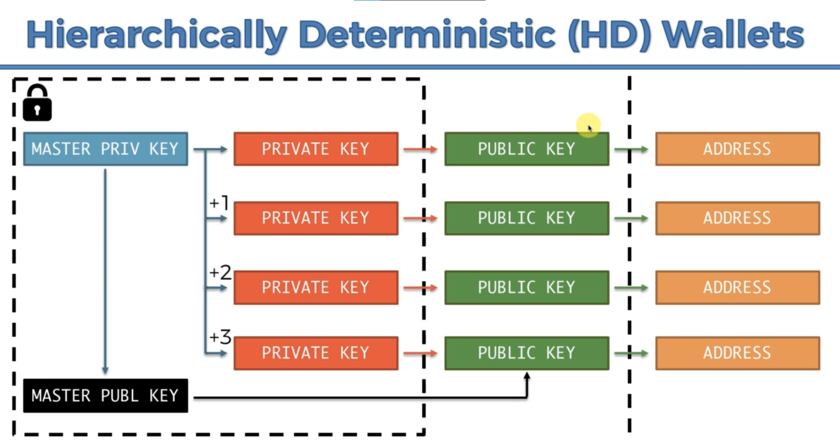

Smart contract: <https://www.freecodecamp.org/news/smart-contracts-for-dummies-a1ba1e0b9575/>

Ethereum: It’s not only a cryptocurrency. We can run applications on blockchains and decentralize the whole system while the application is running on every device. But there are two problems. First, if somebody write a malware and put it on blockchain, every device will be infected. Hence, use Ethereum Virtual Machine. Second, the application can’t be too computational. This will bring problem to the whole network. Therefore, use a concept called “gas”. Every operation on the application is counted, the more compute it needs, the more gas it needs. Then the more money is needed. Due to gas, every application will be the most efficient to save money.

